**Saturday** (Sara Lee)

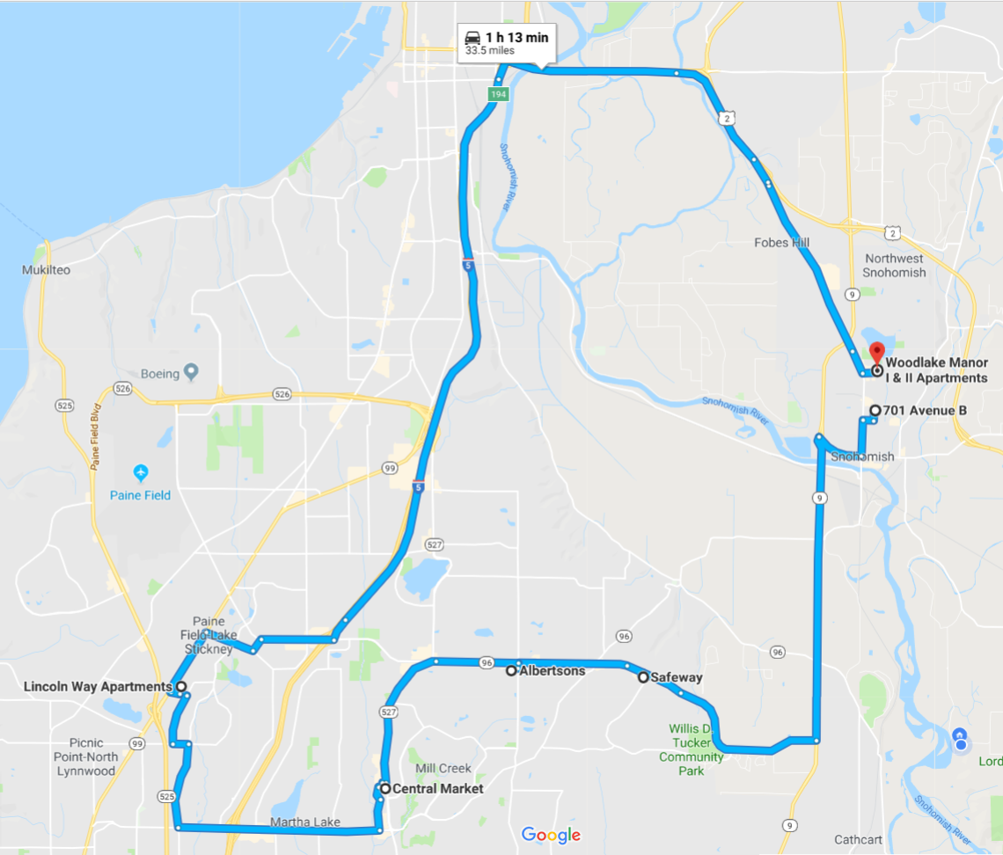

Notes: